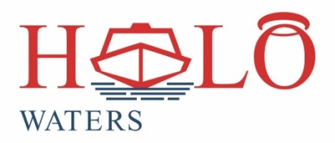 

20 Salvation Road

Opebi

Lagos.

Tel: 08099407155

[www.halowatersng.com](http://www.halowatersng.com)

**BOAT CHARTER APPLICATION FORM**

CUSTOMER INFORMATION

Type of Customer: ……………………………………… (Individual or Corporate)

Name………………………………………………………………………………………….

Telephone No…………………………… Email Address………………………….......

Office Address……………………………………………………………………………….

………………………………………………………………………………………………....

Contact Person (if not Individual)……………………………………………………….

Position………………………………………. Mobile No ………………………………..

Email Address…………………………………..................................................

**CHARTER REQUEST**

Proposed Charter Date…………………………………………………………………..

Destination…………………………………… Pick-Up Point …………………………

Number of Passengers Planned For……………………………………………………

Expected Departure Time……………. Expected Return Time…………………….

Officer to Instruct on Departure…………………… Mobile No…………………….

|  |
| --- |
|  |

**FOR OFFICE USE ONLY**

Amount Approved ……………………… Payment Mode Agreed …………………..

Officer Name and Signature ………………………………………………………........

Manager Approval…………………………………………………………………………..