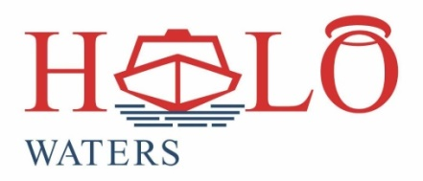
20 Salvation Road
Opebi
Lagos.
Tel: 08099407155
www.halowatersng.com

BOAT CHARTER APPLICATION FORM

CUSTOMER INFORMATION
Type of Customer: ……………………………………… (Individual or Corporate)
Name………………………………………………………………………………………….
Telephone No…………………………… Email Address………………………….......
Office Address……………………………………………………………………………….
………………………………………………………………………………………………....
Contact Person (if not Individual)……………………………………………………….
Position………………………………………. Mobile No ………………………………..
Email Address…………………………………..................................................
CHARTER REQUEST
Proposed Charter Date…………………………………………………………………..
Destination…………………………………… Pick-Up Point …………………………
Number of Passengers Planned For……………………………………………………
Expected Departure Time……………. Expected Return Time…………………….
Officer to Instruct on Departure…………………… Mobile No…………………….
FOR OFFICE USE ONLY
Amount Approved ……………………… Payment Mode Agreed …………………..
Officer Name and Signature ………………………………………………………........
Manager Approval…………………………………………………………………………..

